Lebanese American University

Capstone Design Project 2

Cover Letter

COE – 595 / MCE – 591

Supervisor: Dr. Joe Tekli

Prepared by:

Abbas Abdallah-202101229

Hasan Bazzi 202100867

Mohamad Jaber-202103943

Mohammad Nasser-202102164

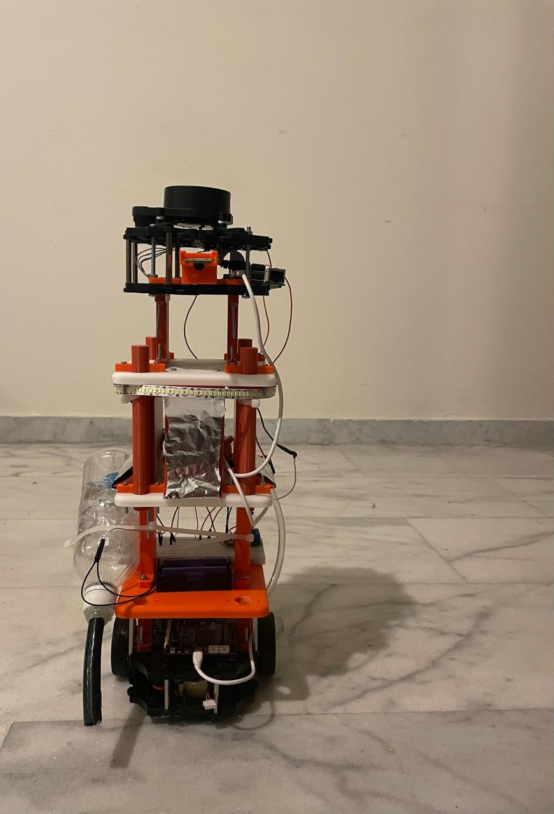

As part of our Capstone Design Project at the Lebanese American University, we designed and developed a fully autonomous service robot capable of performing both **hospital sanitization** and **delivery** tasks. The motivation behind the project stems from the increased demand for contactless solutions in healthcare, especially in light of challenges like pandemics, hospital-acquired infections, and workforce shortages. Our robot aims to reduce human exposure to contaminated environments while ensuring routine deliveries of medication, food, or medical supplies are performed reliably.

The robot is built on the **TurtleBot3 Burger platform** and uses a **Raspberry Pi 4** as the main computational unit. It employs **LiDAR-based SLAM** (Simultaneous Localization and Mapping) for autonomous navigation and environment mapping. The navigation system allows the robot to traverse hospital hallways, avoid obstacles, and reach designated rooms with high accuracy. Once inside a room, it can perform predefined tasks including sanitization and delivery.

The sanitization module combines three mechanisms:

1. **UV-C light disinfection** for sterilizing surfaces and air,
2. **Vacuum cleaning** activated through AI-based dust detection using a trained **ResNet18 image classification model**, and
3. **Water mopping** controlled by real-time water level sensing and pump activation.

The delivery function is handled through custom-designed trays mounted on the robot's middle layers, suitable for carrying medication, food, or samples. The entire system was modeled in CAD, 3D printed, and tested in a real-world environment. Throughout development, we addressed mechanical design challenges such as robot balance, tier spacing, and power isolation, and implemented intelligent hardware control using GPIO, relays, and sensor feedback.

Our project demonstrates a successful integration of **ROS2 navigation**, **embedded systems**, **machine learning**, and **practical hardware engineering** to produce a smart robot capable of aiding hospital staff in routine but critical tasks. It provides a scalable and efficient solution for improving hygiene and workflow in healthcare environments.